|  |  |
| --- | --- |
| *Pacific Gas and Electric Company* | |
| Release 9.6.4 Installation Guide | |
|  |  |
|  |  |
| Project | ED AM/GIS |
|  |  |
| Prepared by | P1Pc@pge.com |
| Date | 9/2/2015 |
| Version | 1.0 |
| Version Type | Draft |

|  |  |  |  |
| --- | --- | --- | --- |
| Revision History | | | |
| Document # | Date | Author | Summary of Changes |
| 1.0 | 9/2/2015 | Philip Penn | Initial Document Creation |
|  |  |  |  |

# Introduction

## Purpose

This document is intended to detail the implementation and configuration steps required to implement Release 9.6.4 Installation Guide. This document describes the various configuration aspects required to complete any manual or automatic patch associated with this release. Each section in this document contains the steps required to patch the system in production.

## Terms Used

|  |  |
| --- | --- |
| OOTB | Out of the box. Unmodified from the commercial version. |
| TFS | Team Foundation Server |

## External Documents

Referenced are any external configuration documents or exports. These are documents that contain more detailed information about configuring a system or documents that can be loaded into an application to perform the configuration detailed in this document.

1. Supporting documentation folder
   1. **TFS documentation location:**

$/EDAMGIS/Source_Development_10_2_1/Documentation/Data Model/Release Documentation/EDER/9.6.4

## List of Fixes

Below is the list of change requests detailing all fixes for the data model for this release:

|  |  |
| --- | --- |
| **Item Number** | **Title** |
| [2361](http://edappgistfsprd1:8080/tfs/ElectricDistCollection/EDAMGIS/_workitems#_a=edit&id=23365)2 | Master TFS DM 9.6.4 |
| [23610](http://edappgistfsprd1:8080/tfs/ElectricDistCollection/EDAMGIS/_workitems#_a=edit&id=23363) | Create EDGIS.ZPGEVW_TRANSFORMER_NONOH in EDER Maintenance/Publication |

Contents

1 Introduction 3

1.1 Purpose 3

1.2 Terms Used 3

1.3 External Documents 3

1.4 List of Fixes 4

2 EDGIS 6

2.1 23610: Create EDGIS.ZPGEVW_TRANSFORMER_NONOH in EDER Maintenance/Publication 6

2.2 Update Data Model Version Table 7

3 Known Issues 8

# EDGIS

## 23610: Create EDGIS.ZPGEVW_TRANSFORMER_NONOH in EDER Maintenance/Publication

1. Open a command prompt and execute the below SQL script with the following command on the target database:  
   sqlplus edgis/<edgispassword>@<targetdatabase> @create_zpgevw_transformer_nonoh.sql  
     
   Link to SQL script: [http://edappgistfsprd1:8080/tfs/ElectricDistCollection/EDAMGIS/_versionControl#path=%24%2FEDAMGIS%2FSource_Development_10_2_1%2FDocumentation%2FData+Model%2FRelease+Documentation%2FEDER%2F9.7.4%2Fcreate_zpgevw_transformer_nonoh.sql&_a=contents](http://edappgistfsprd1:8080/tfs/ElectricDistCollection/EDAMGIS/_versionControl%23path=%24%2FEDAMGIS%2FSource_Development_10_2_1%2FDocumentation%2FData+Model%2FRelease+Documentation%2FEDER%2F9.7.4%2Fcreate_zpgevw_transformer_nonoh.sql&_a=contents)
2. Copy the output to a log file, name it “create_zpgevw_transformer_nonoh.log” and attach it to the TFS ticket for this request.

## Update Data Model Version Table

**Database Configuration:**

1. Open SQL Plus.
2. Log in using the same server and user as was used in section 2.1.  
     
   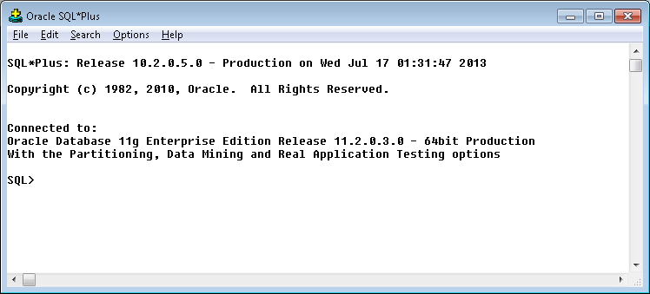
3. Run the SQL below:

update pgedatamodelversion set currentidc='N' where currentidc='Y';

insert into pgedatamodelversion (OBJECTID, CURRENTIDC, DATEAPPLIED, APPLIEDBYPERSONNAME, MODELVERSION) values (**SDE.VERSION_USER_DDL.NEXT_ROW_ID('EDGIS',(select registration_id from sde.table_registry where table_name='PGEDATAMODELVERSION'))**,'Y',sysdate,'**Philip Penn**','**9.6.4** GOLD');

 commit;

# Known Issues

<Please List any other issues encountered here while following the document>